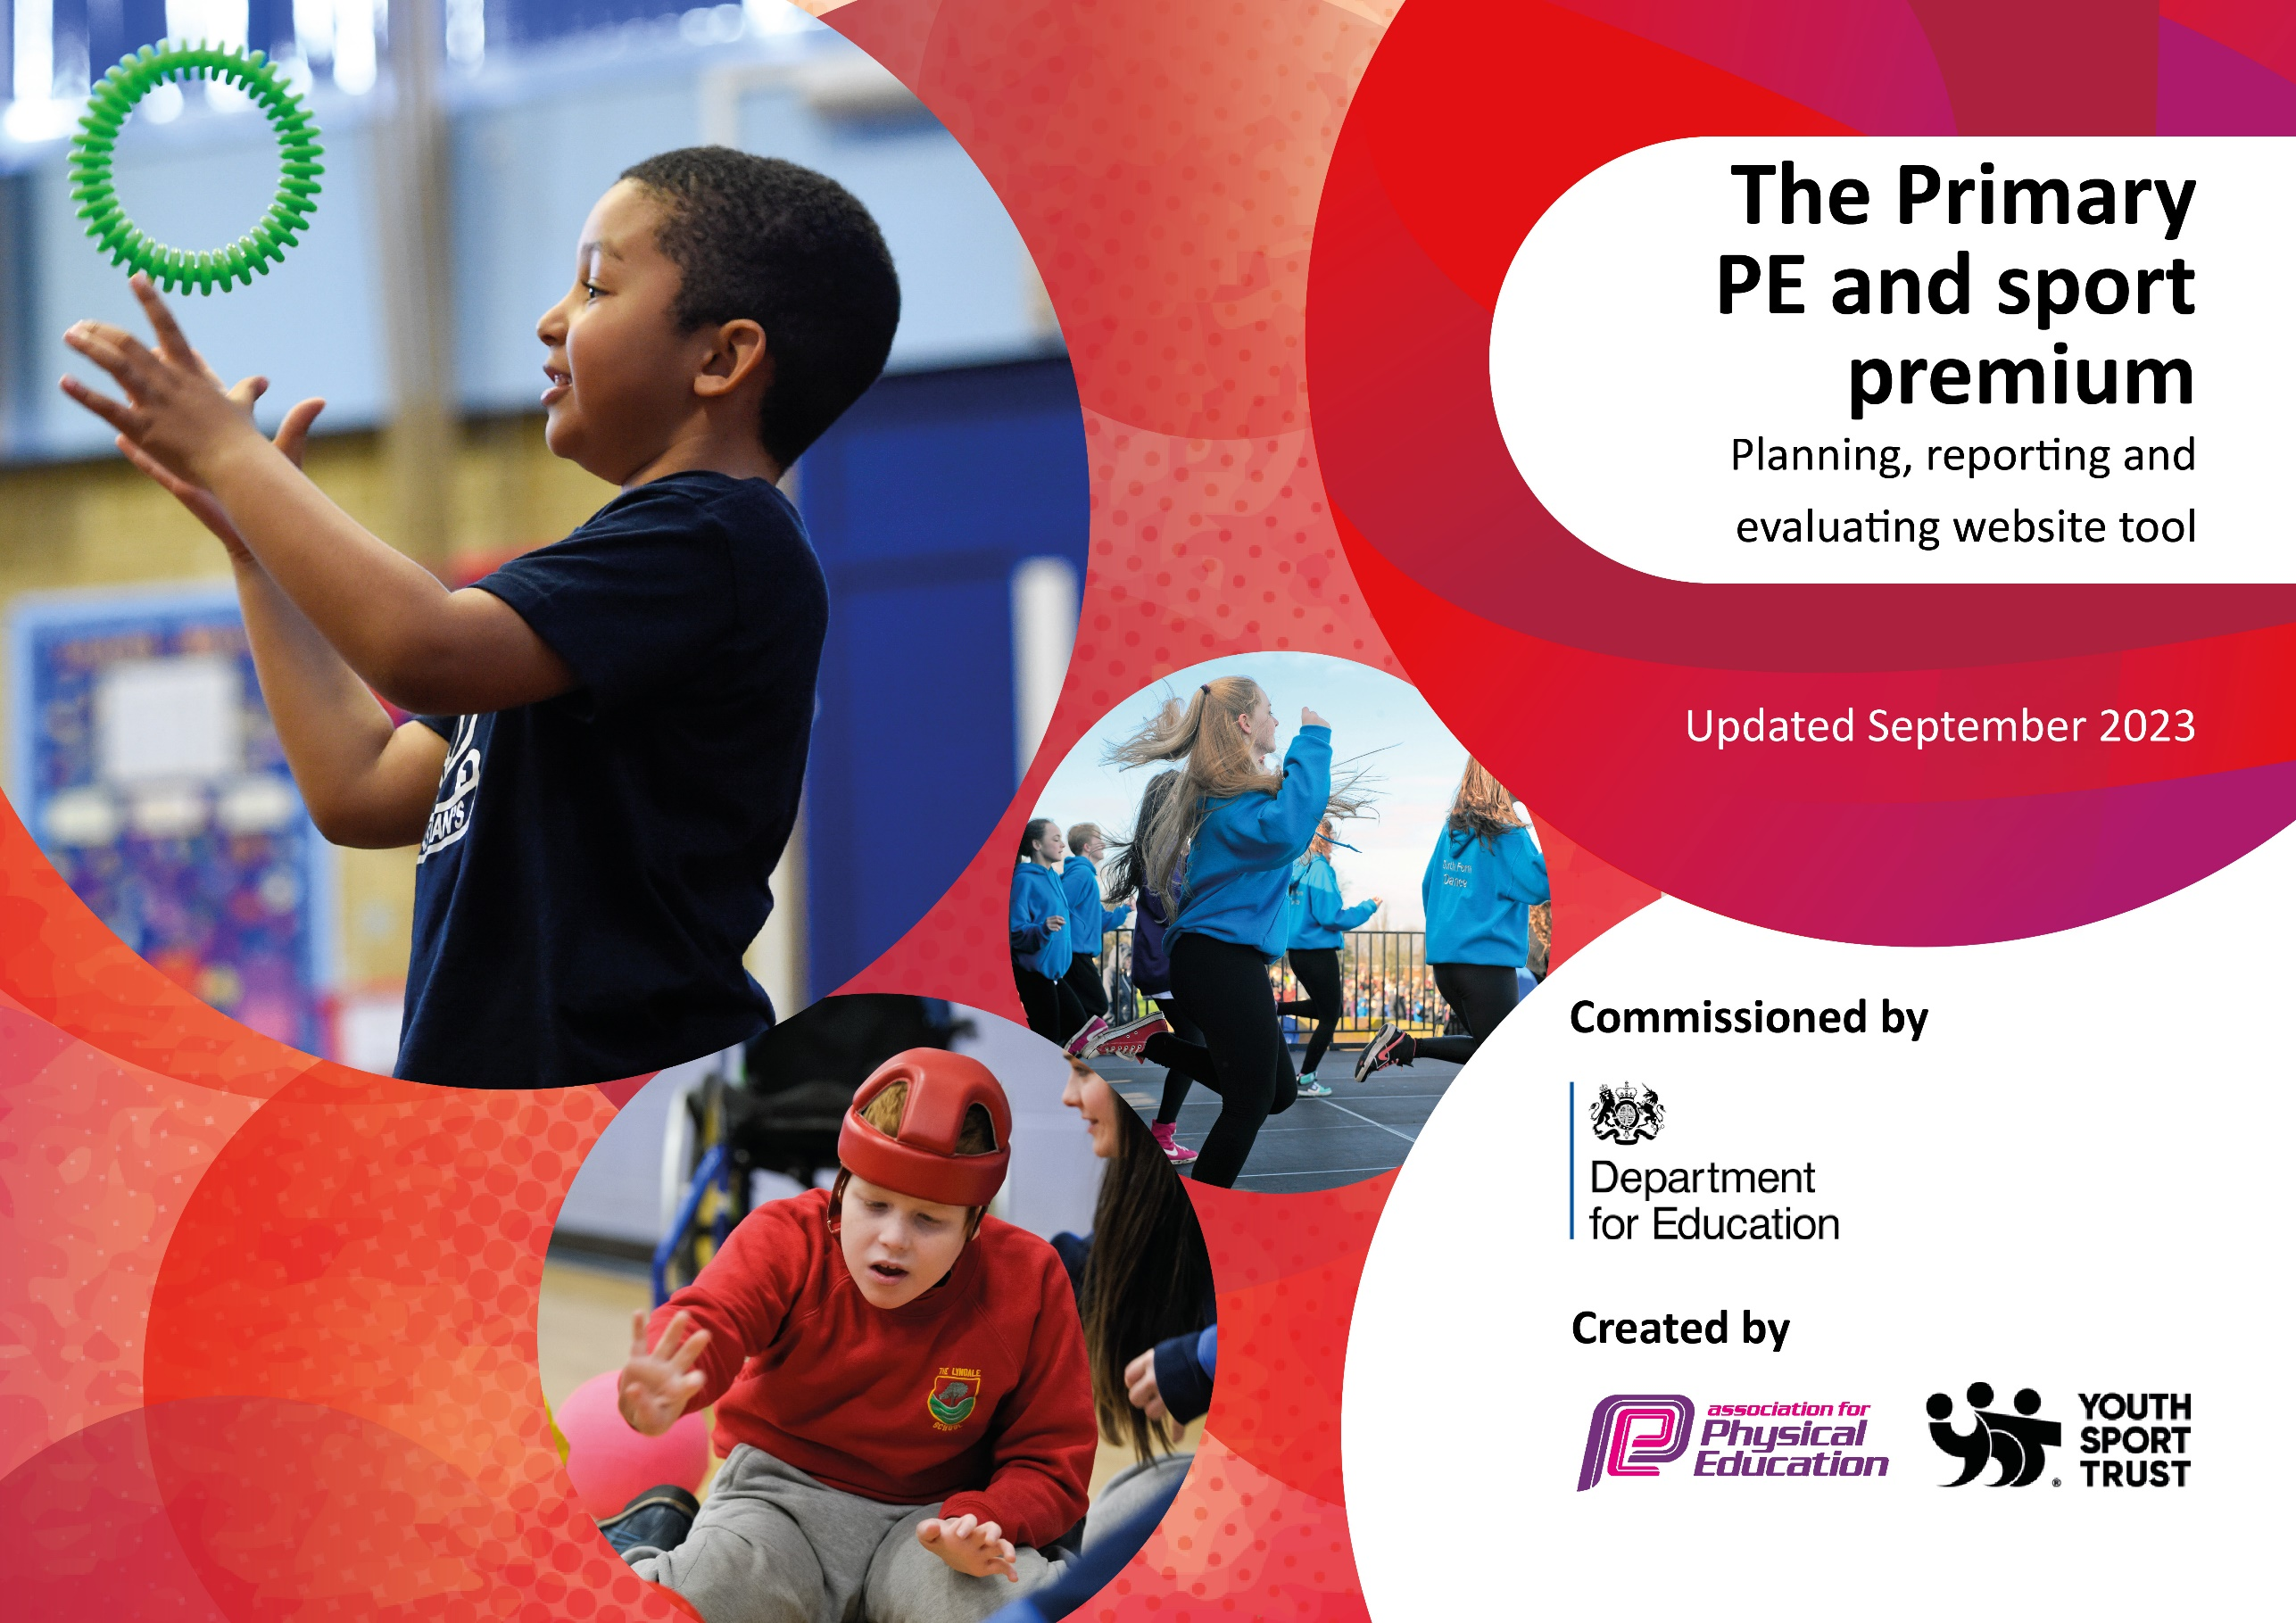

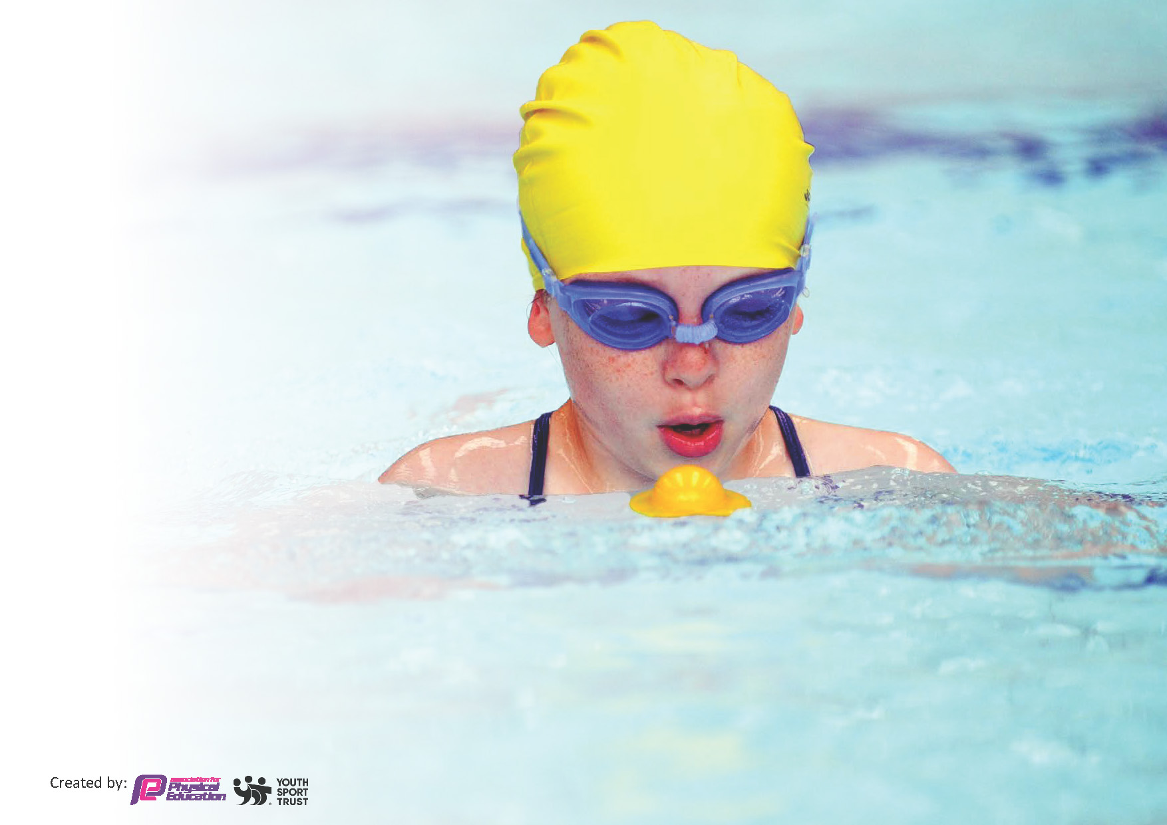
This template can be used for multiple purposes:
by:
- It enables schools to effectively plan their use of the Primary PE and sport premium
- It helps schools to meet the requirements (as set out in guidance) to publish information on their Primary PE and sport premium
- It will be an effective document to support Ofsted inspections enabling schools to evidence progress in Physical Education (PE) and evidence swimming attainment, which forms part of the PE National Curriculum. We would recommend schools consider
the Intent, Implementation and Impact of any spend, as examined within the Education Inspection Framework.

It is important that your grant is used effectively and based on school need.

Schools must use the funding to make additional and sustainable
improvements to the quality of the PE, School Sport and Physical Activity (PESSPA)
they offer. This means that you should use the Primary PE and sport premium to:

- Build capacity and capability within the school to ensure that improvements made now will benefit pupils joining the school in future years
- Develop or add to the PESSPA activities that your school already offers.

The Primary PE and sport premium should not be used to fund capital spend projects; the school’s core budget should fund these. Further detail on capital expenditure can be found in the updated Primary PE and sport premium guidance.

The Primary PE and sport premium guidance, outlines 5 key priorities that funding should be used towards. It is not

necessary that spending has to meet all the key priorities, you should select the priorities that you aim to use any funding towards.

Although completing this template is not a requirement for schools, schools are required to publish details of how they spend this funding. Schools must also outline what the impact this funding has had on pupils’ PE and sport participation and attainment and how any spending will be sustainable in the future. All funding must be spent by 31st July 2024.

The Department for Education has worked closely with the Association for Physical Education (afPE) and the Youth Sport Trust (YST) to develop this template and encourages schools to use it. This template is an effective way of meeting the reporting requirements of the Primary PE and sport premium.
Review of last year’s spend and key achievements (2022/2023)

We recommend you start by reflecting on the impact of current provision and reviewing your previous spend.

Activity/Action | Impact | Comments
- WOW Assessments planned in across the year groups – tracking fitness levels of all individuals.  - Parent access to create links across school and home life  - CPD for all teachers with targets led and developed between coach and individuals  - ‘Sharing’ set up at the end of units to celebrate skills and language taught in lessons | - Wow successful across the school – next steps is further enhance CPD with support from Premier. Challenge cards to be used in school to create links to home opportunities  - CPD sheets adapted and develop from Premier in line with school needs – teacher lead on their development and adapt as necessary – staff audits show increased levels of confidence in leading PE lessons  - ‘Sharing adapted and embedded with further CPD need to focus on vocab across classes – differentiation in this element and showcase of range of skills shown | - New elements within the school allow for deeper development and learning but also presenting new opportunities to enhance 60 minute active days across school

Key priorities and Planning
This planning template will allow schools to accurately plan their spending.

Action – what are you planning to do | Who does this action impact? | Key indicator to meet | Impacts and how sustainability will be achieved? | Cost linked to the action
WOW assessment CPD to continue but to be withdrawn over the year for teachers to lead in coming years. | Teacher CPD  Presenting opportunities for children to be more active and families to be involved in successes  Activities at home to try following WOW days | Key indicator 1 -The engagement of all pupils in regular physical activity – the Chief Medical Officer guidelines recommend that all children and young people aged 5 to 18 engage in at least 60 minutes of physical activity per day, of which 30 minutes should be in school.  Key Indicator 3 – Increased confidence, knowledge and skills of all staff in teaching PE and Sport  Key indicator 4: Broader experience of a range of sports and activities offered to all pupils. | More pupils meeting their daily physical activity goal, more pupils encouraged to take part in PE and Sport Activities.  WOW can be implemented across school with reduced expenditure on coaches  Staff improved confidence to lead these activities – active in encouraging the children to achieve more including to undertake extra activities inside and outside of school to their level | £1800 for WOW online access and support

CPD sessions from Premier to support enhance delivery of PE lessons | Teachers / HLTA and TA’s | Key Indicator 3: Increased confidence, knowledge, and skills of all staff in teaching PE and sport.  Key indicator 5: Increased participation in competitive sport. | Teachers achieve their own goals to improve Teaching and Learning – continually individual progress throughout the year | Part of £18000 package from Premier to support lessons, lunchtime provision and after school clubs
Use of Premier to enhance lunchtimes and lead on a range of extra curricular activities | Lunchtime Supervisors / TA’s to engage in best practice during lunchtimes | Key indicator 1 -The engagement of all pupils in regular physical activity – the Chief Medical Officer guidelines recommend that all children and young people aged 5 to 18 engage in at least 60 minutes of physical activity per day, of which 30 minutes should be in school.  Key Indicator 3 – Increased confidence, knowledge and skills of all staff in teaching PE and Sport  Key indicator 4: Broader experience of a range of sports and activities offered to all pupils. | Teaching of skills to engage pupils across lunchtimes  Children exposed to and able to access a wide range of sports | Part of £18000 package from Premier to support lessons, lunchtime provision and after school clubs

Key achievements 2023-2024
This template will be completed at the end of the academic year and will showcase the key achievements schools have made with their Primary PE and sport premium spending.

Activity/Action | Impact | Comments
WOW assessment CPD to continue but to be withdrawn over the year for teachers to lead in coming years.  CPD sessions from Premier to support enhance delivery of PE lessons  Use of Premier to enhance lunchtimes and lead on a range of extra curricular activities | Clear trend of improvement in all year groups. Children achieving higher levels of fitness when compared to wider regional figures. Home support for being active out side of school hours.  Increased confidence in leading PE lessons  Staff able to lead different games across lunchtimes – strong – high number engagement to after school clubs | Continue to embed and enhance with workshops for parents during the academic year.  Premier to support initially next year and remove scaffold of support until review in Summer 25  Continue to offer this provision through 24.25 giving further opportunities for pupil voice to lead games

Swimming Data
Meeting National Curriculum requirements for swimming and water safety.
Priority should always be given to ensuring that pupils can perform safe self-rescue even if they do not fully meet the first two requirements of the National Curriculum programme of study

Question | Stats: | Further context  Relative to local challenges
What percentage of your current Year 6 cohort can swim competently, confidently and proficiently over a distance of at least 25 metres? | 75%
What percentage of your current Year 6 cohort can use a range of strokes effectively [for example, front crawl, backstroke, and breaststroke]? | 75%

What percentage of your current Year 6 cohort are able to perform safe self-rescue in different water-based situations? | 70%
If your schools swimming data is below national expectation, you can choose to use the Primary PE and sport premium to provide additional top-up sessions for those pupils that did not meet National Curriculum  requirements after the completion of core lessons. Have you done this? | N/A
Have you provided CPD to improve the knowledge and confidence of staff to be able to teach swimming and water safety? | Yes | Supported with guidance from Local Swimming Pool

Signed off by:

Head Teacher: | David Simmons
Subject Leader or the individual responsible for the Primary PE and sport premium: | David Simmons Head teacher
Governor: | Mr Higgins
Date: | 24.06.24

